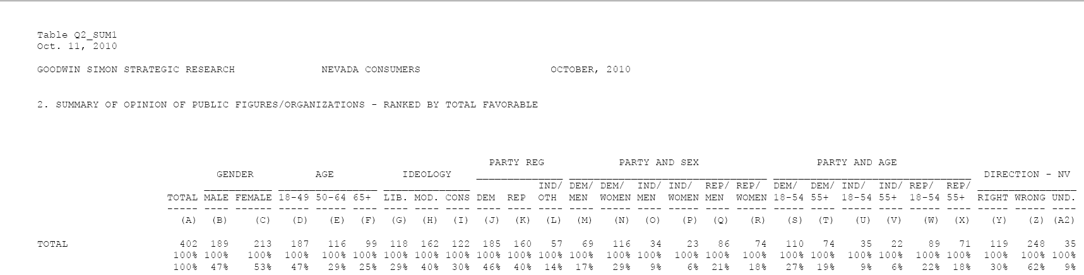

JC:Users:jc:Desktop:Screen shot 2011-01-07 at 9.46.10 AM.png

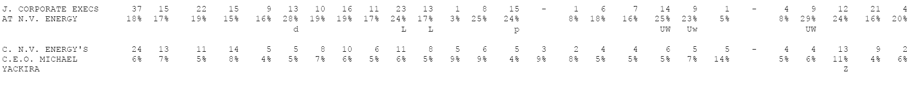

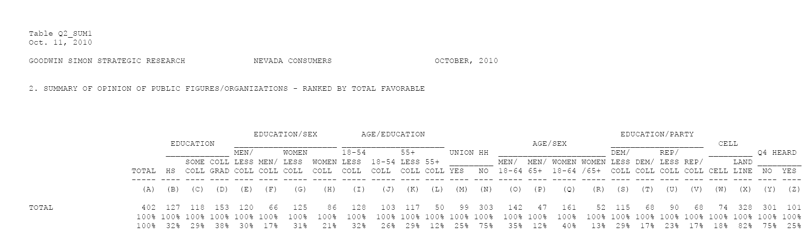





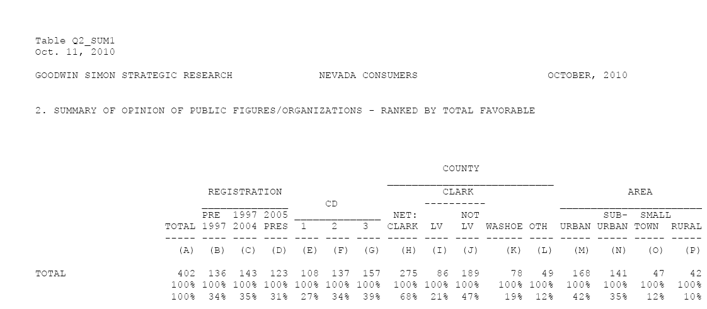



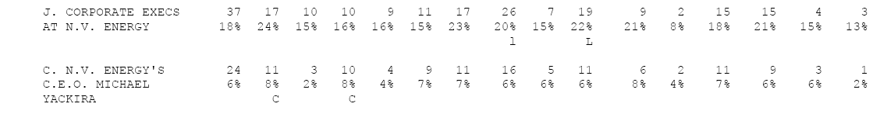

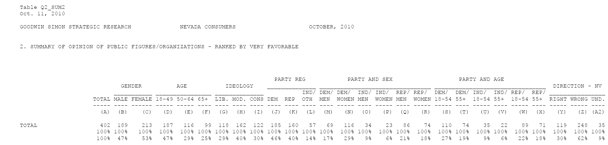





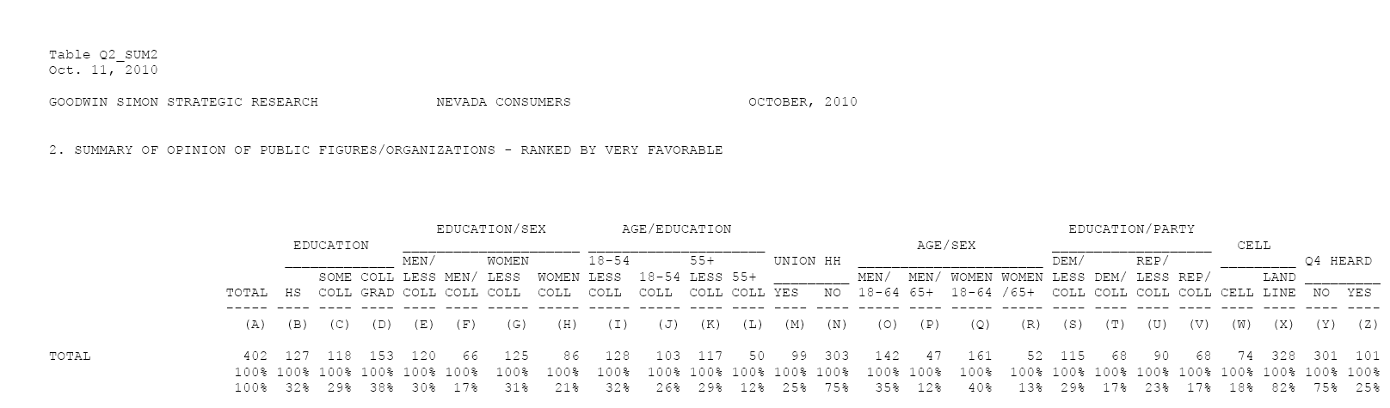



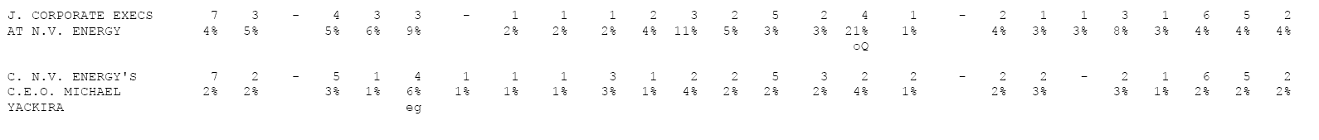

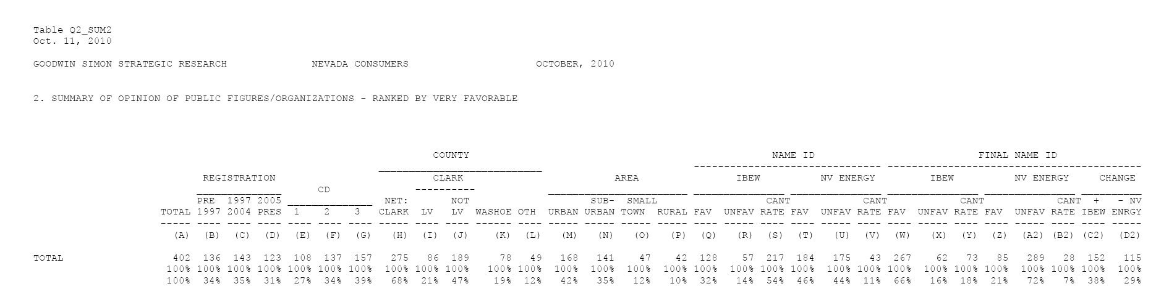





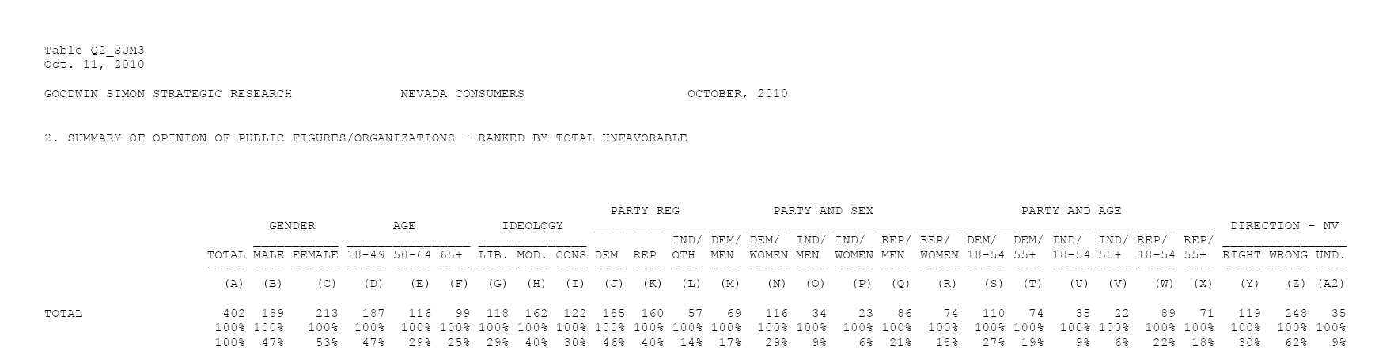







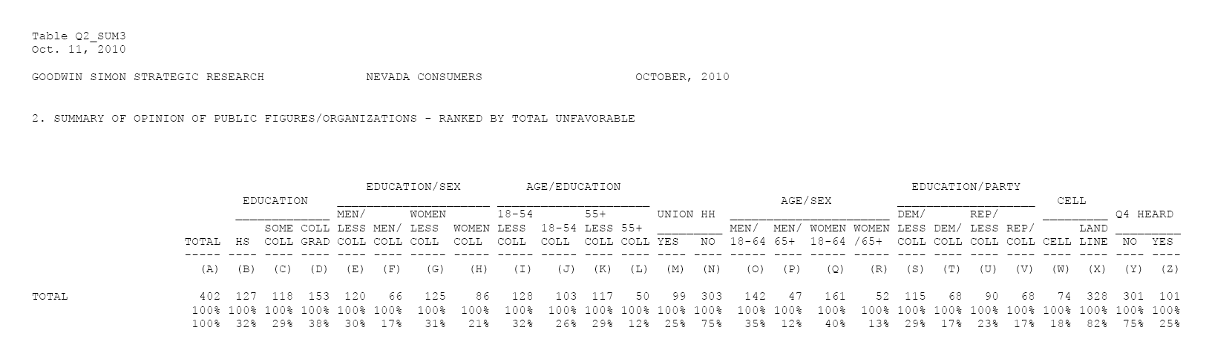



JC:Users:jc:Desktop:Screen shot 2011-01-07 at 12.24.48 PM.png



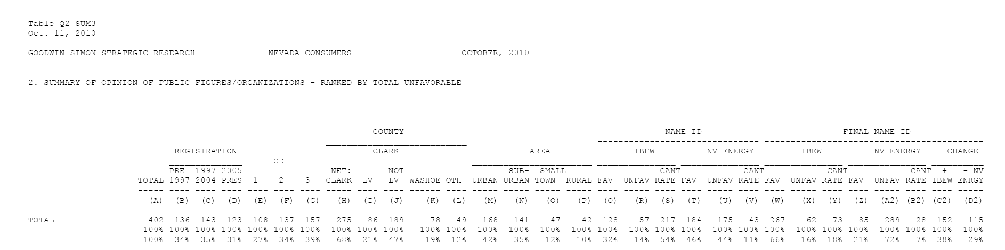







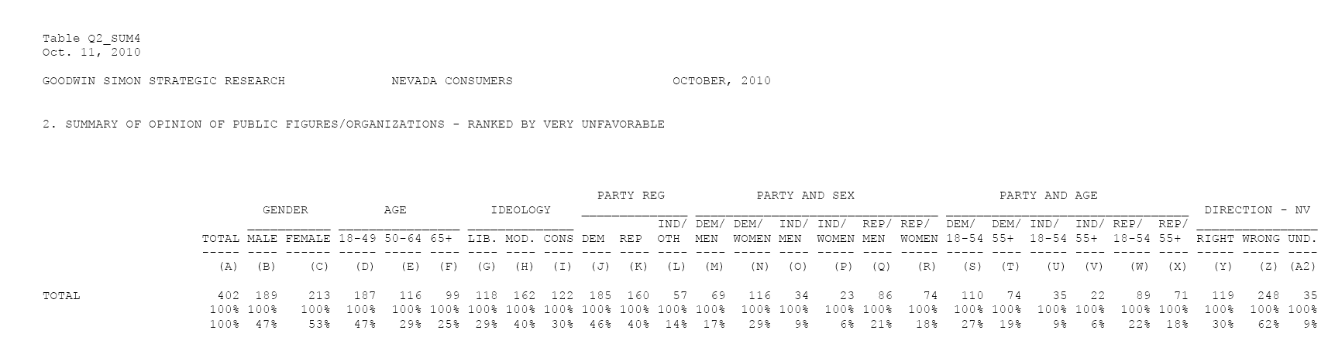





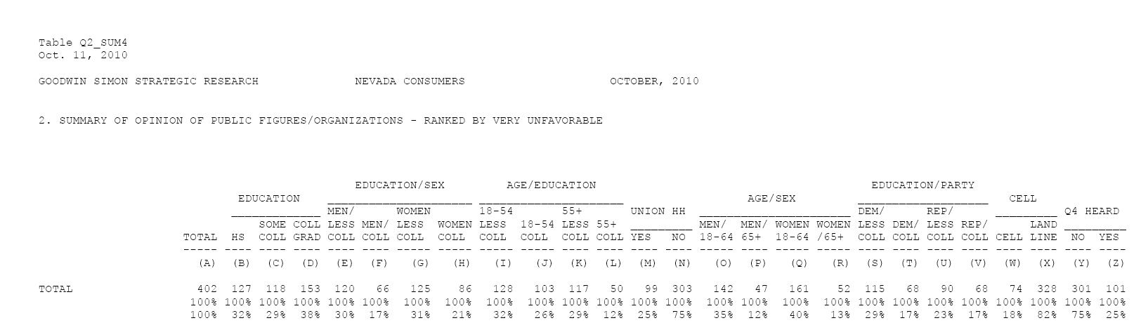





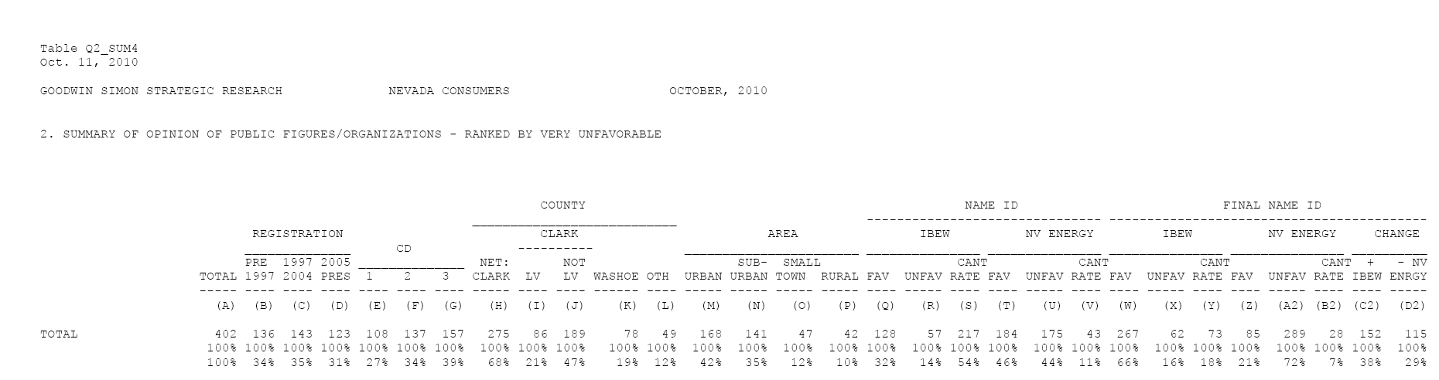





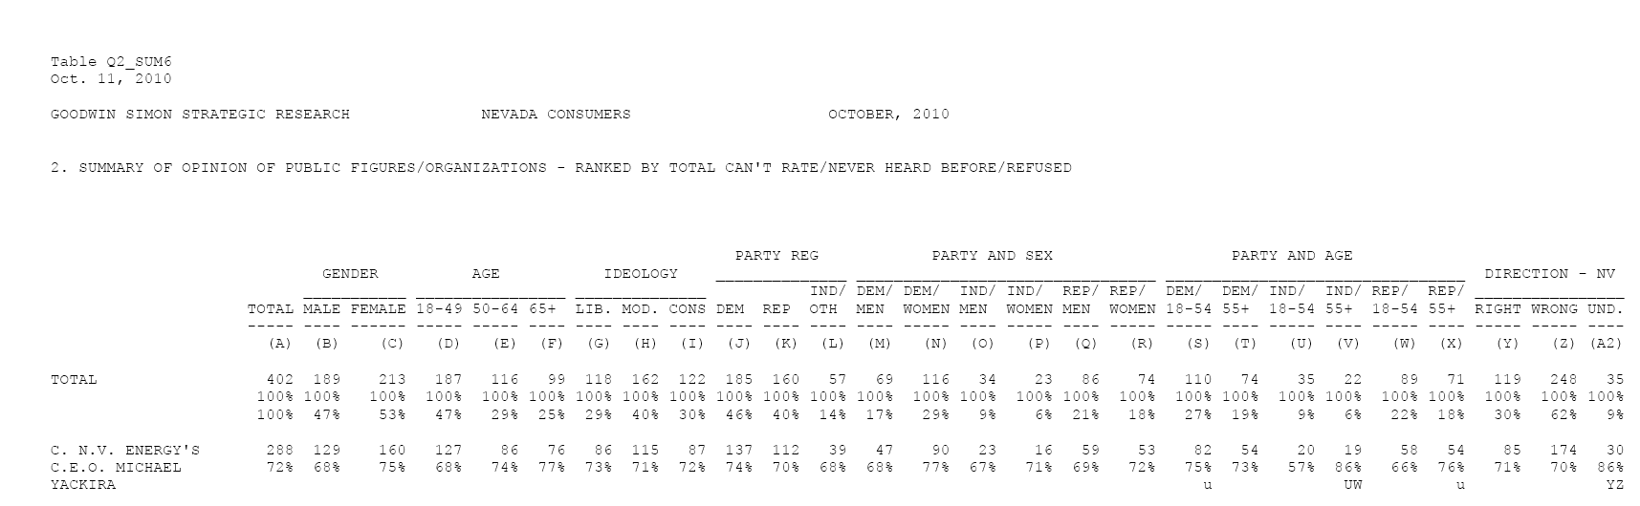



JC:Users:jc:Desktop:Screen shot 2011-01-07 at 10.03.39 AM.png

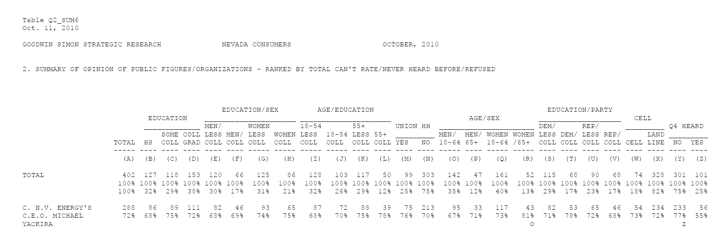



JC:Users:jc:Desktop:Screen shot 2011-01-07 at 10.04.06 AM.png

